Camerer, C. F. (1989). An Experimental Test of Several Generalized Utility Theories. Journal of Risk and Uncertainty

This is an experiment about lotteries with uncertain payoffs. You will be given a series of choices between two lotteries. For each pair of lotteries, you should indicate which of the two lotteries you prefer to play. You will actually get the chance to play one of the lotteries you chose, so you should think carefully about which lotteries you prefer.
Here is a pair of lotteries like the ones you will see: [Figure A. 1 is showing]
The outcomes of the lotteries will be determined by a random number between 01 and 100. Each number between (and including) 01 and 100 is equally likely to occur. In the example above, the left lottery, labeled A, pays nothing (0) if the random number is between 01 and 40. Lottery A pays five dollars ($5) if the random number is between 41 and 100. Notice that the picture is drawn so that the height of the line between 01 and 40 is 40% of the distance from 01 to 100. The rectangle around $5 is 60% of the distance from 01 to 100.
In the example above, the lottery on the right, labeled B, pays nothing (0) if the random number is between 01 and 50, five dollars ($5) if the random number is between 51 and 90, and ten dollars ($10) if the random number is between 91 and 100.

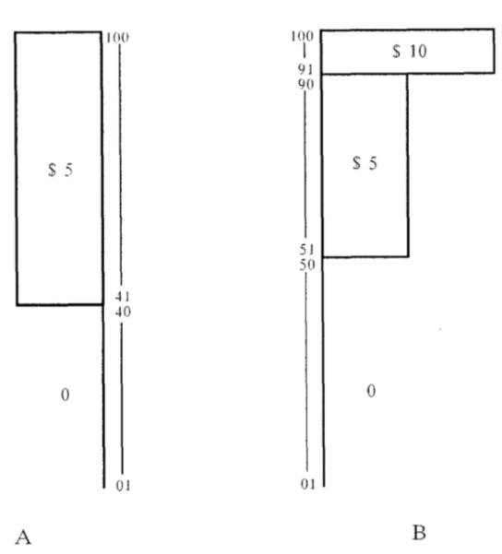

As with lottery A, the heights of the lines in lottery B represent the fraction of the possible numbers that yield each payoff. For example, the height of the $10 rectangle is 10% of the way from 01 to 100. The widths of the rectangles are proportional to the size of their payoffs. In lottery B, for example, the $10 rectangle is twice as wide as the $5 rectangle.
Some of the lotteries involve large payoffs ($10,000 or $25,000), some involve smaller payoffs ($5 or $10), and some involve losses (-$5 or -$10). The foundation that is sponsoring this research cannot afford to pay the largest payoffs, but you will get to play one of the lotteries with smaller payoffs.
Each pair of lotteries is on a separate page. On each page, you should indicate which of the lotteries you prefer to play by circling either A, if you prefer the A lottery, or B, if you prefer the B lottery. You should approach each pair of lotteries as if it is the only pair of lotteries you are considering, because you are only going to play one of the many lotteries.

After you have worked through all the pairs of lotteries, raise your hand and an experimenter will bring you two containers of cardboard tickets. You will select one ticket from each of the two containers. One container has 100 tickets numbered 1 through 4 (25 numbered 1, 25 numbered 2, etc.); the other container has 100 tickets number 01 through 100. (If you wish, you may examine the whole containers of tickets after the experiment.)

The first ticket determines which pair of lotteries has been chosen. Some of the pages you have are numbered 1through 4 in the upper right hand corners; the first ticket you choose determines which of those pages you will play. If the first ticket you chose is numbered 3, for example, then you will play whichever lottery you picked on page number 3.

The second ticket is the random number which determines the outcome of the lottery you chose, on the page determined by the first ticket. For instance, suppose you picked the A lottery on the first page of these instructions. If the random number was 37, you would win nothing; if it was 93, you would get $5. If you picked the B lottery and drew the number 37, you would get nothing; if it was 93, you would get $10.

Therefore, your payoff is determined by three things: by which page is chosen, as determined by the first ticket you chose; by which lottery you picked on that page; and by the outcome of that lottery. This procedure is explained again on the last page.

This is not a test of whether you can pick the best lottery in each pair, because none of the lotteries are necessarily better than the others. Which lotteries you prefer is a matter of personal taste. The people next to you will have different lotteries, and may have different tastes, so their responses should not matter to you. Please work silently, and make your choices by thinking carefully about each lottery. Any changes or erasures will make you ineligible for a payoff.

After you have chosen one lottery on each page, raise your hand and the experimenters will come around with the containers of tickets. After you have chosen your tickets and determined your payoff, sign the receipt on the last page, give your questionnaire to one of the experimenters, and you will be given your payoff in cash. Then you are free to leave. Feel free to ask questions now, or during the experiment.

You have now finished making choices. Follow the instructions below in numerical order.

- Please check to be sure that you have made one choice (by circling either A or B) on each page.
- Raise your hand. The experimenters will bring the two containers of tickets. 3) Draw one ticket from each container, then write their numbers below.
- Draw one ticket from each container, then write their numbers below.

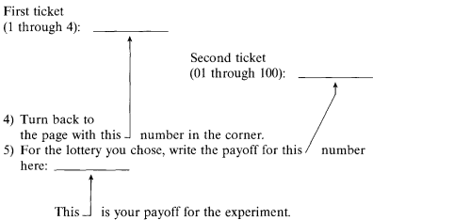

6) Sign the receipt below and bring this questionnaire to an experimenter. He will give you your payoff, or collect it from you if it is negative. Be sure to return your tickets to the experimenter.

Name: _________________________Received____________________

Social Secutiry No. ____________________Date ____________________

