Coller, M., Harrison, G. W., and Rutström, E. E. (2003). Are discount rates constant? Reconciling Theory and Observation. Working Paper. Department of Economics, College of Business Administration, University of Central Florida.

Experiments with Front End Delay

WELCOME TO THE EXPERIMENT
THESE ARE YOUR INSTRUCTIONS

This is an experiment in the economics of decision making. Your participation in this experiment is voluntary. However, we think you will find the experiment interesting, you will be paid for your participation and you could make a considerable amount of additional money. The instructions are simple and you will benefit from following them carefully. Please take a few minutes to read them through.
One person in this room will be randomly chosen to receive a large sum of money. If you are the individual chosen to receive this money (the “Assignee”), you will have a choice of two payment options; option A or option B. If you choose option A, you will receive $500 in 30 days. If choose option B, you will receive more than $500 in more than 30 days.
You will be asked to choose the payment option that you would prefer (if you are chosen to be the Assignee) in each of 15 different payoff alternatives. You will make your choices on a table that looks like the table on the next page. Note that each of the 15 payoff alternatives will pay $500 in 30 days (option A) and $500+x in more than 30 days (option B), where x differs under each payoff alternative. Next to each payoff alternative you will circle the payment option (A or B) that you would prefer if chosen to be the Assignee. At the end of the experiment, one of the 15 payoff alternatives will be selected at random. The Assignee will be paid based on the payment option he or she chooses under the payoff alternative selected.

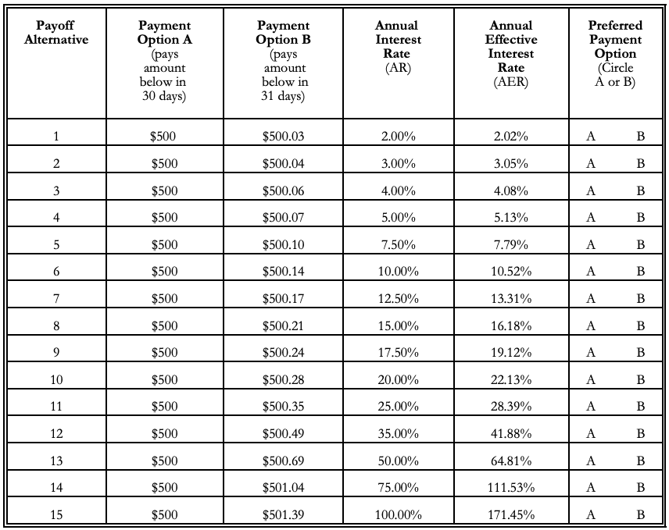

In the table there are two columns labelled “Annual Interest Rate” and “Annual Effective Interest Rate”. To explain these terms, let us consider the following example payoff alternative (number 10 in the table above):
Option A pays $500.00 30 days from today
Option B pays $500.28 31 days from today
In this example, if you choose option B you will earn an interest rate (quoted in annual terms) of 20.00% on the $500 by postponing payment beyond the 30 days. Since this is compounded daily your effective interest rate (quoted in annual terms) is 22.13%. (Daily compounding is consistent with general banking practices on CDs, credit cards, lines of credit, savings accounts, etc.) The effective interest rate is that rate earned on the initial balance ($500 in this example) after accounting for the fact that in each compounding period interest is earned on the initial balance plus all interest accumulated in the preceding compounding periods.
We will now discuss some choices you may make.
Suppose you would like to choose payment option A over option B but do not wish to spend the money for the additional time between A and B. We spoke with several banks in the Columbia area and found that the alternative which most closely resembles choosing option B would be to place the $500 in a savings account. These accounts generally do not require a minimum deposit, and money can be withdrawn at any time. Currently, First National Bank and Wachovia pay one of the best rates on passbook savings. This account is compounded daily and earns an annual interest rate of 1.00% with an annual effective interest rate of 1.01%.
Note that other safe investment opportunities do exist, but that they may not be close substitutes for choosing option B. For example, banks also offer Certificates of Deposit (CDs). CDs generally require a minimum initial balance of $500 or $1000, depending on the bank. Like option B, the CD guarantees payment with interest. However, CDs are offered for limited investment periods (i.e., 30 days, 90 days, 6 months, etc.) that may not correspond to the timing of option B. Furthermore, you are required to leave your money in the CD for the agreed upon time. There is a significant penalty for early withdrawal, and you must either invest in anther CD or move your money to another type of account at the end of the agreed upon time. Currently, in Columbia, Southtrust Bank has one of the best rates on CDs with a minimum balance of $500. This CD is compounded daily and currently earns an annual interest rate of 1.64% with an annual effective interest rate of 1.65%.
Alternatively, suppose you would like to choose payment option B over option A, but you also would like to spend the money before you receive payment under option B. Rather than choosing option A, you could borrow the $500 and repay it when you receive the payment from option B. The easiest way to do this would be to obtain a cash advance from your credit card or line of credit, or charge your purchases directly.
Most college students with a reasonably clean credit history can qualify for a credit card. We checked current credit card rates advertised around this campus. The cards we saw advertised charge permanent rates in the range of 12.99% to 15.99%.
If you do not have a credit card or line of credit, but you have a good credit rating, you can receive a line of credit (usually in the form of overdraft protection or cash reserve on your checking account) within a day or two of applying for it. Currently, the banks we spoke with charge annual rates between 16% and 19% on their cash reserve or overdraft protection accounts.
In a few moments we will ask each individual in this room to choose the payment option he or she would prefer under each payoff alternative if chosen to be the Assignee. All decisions will be written and will not be revealed to any other participants. All decisions will be treated confidentially.
HOW IS THE PAYOFF ALTERNATIVE SELECTED?
You will complete two copies of a payoff table like the one above. Note that the payoff alternatives are numbered 1-15. You will be asked to circle your preferred payoff option under each payoff alternative on both tables. You will then give one copy of the table to the experimenter and keep one copy for yourself (be sure that you have marked the same choices on both copies). After the experimenter has collected everyone’s decisions, one numbered ball will be drawn from the Bingo cage that you see in front of the room. The cage will contain balls numbered from 1-15. The payoff alternative whose number coincides with the number on the ball will be the payoff alternative under which the Assignee will be paid. Therefore, all payoff alternatives are equally likely to be selected.
Remember, the Assignee will be paid based on the payment option he or she chooses for that payoff alternative. For example, suppose you are chosen to be the Assignee and you chose payment option A under payoff alternative 5. If the ball picked reads “5,” you will receive $500 30 days from today.
HOW IS THE ASSIGNEE DETERMINED?
Your payoff table has an ID number at the top of the page, and everyone in the room has a different ID number. After the payoff alternative is chosen, Bingo balls with numbers corresponding to these ID numbers will be placed in the Bingo cage. One of these balls will then be drawn to determine the assignee. If the Bingo ball drawn has your ID number, you are the Assignee. Note that all individuals in this room have an equal chance of being the Assignee.
HOW WILL THE ASSIGNEE BE PAID?
An experimenter will immediately take the Assignee to the office of Georgene Dance, a Notary Public, in the Moore School of Business. There the Assignee will receive a certificate which is redeemable under the conditions dictated by his or her chosen payment option under the selected payoff alternative. This certificate is guaranteed by Professor Elisabet Rutström, Beamlab Director, Moore School of Business, University of South Carolina. Professor Rutström’s signature is notarized by Georgene Dance and thus the certificate is a binding legal contract between the Assignee and Professor Rutström. A sample certificate is shown below. (see the paper).
At any time on or after the payment date the certificate can be redeemed for a University of South Carolina check in the office of Georgene Dance, Administrative Assistant, Department of Economics, room 412, Business Building. Alternatively, the assignee may mail the certificate to Professor Rutström at the address provided, and Professor Rutström will then mail a university check to the assignee.
To demonstrate the procedures used in this experiment we will run a short trial experiment. One person in this room will be randomly chosen to receive a quantity of Hershey’s Chocolate Kisses. If you are the individual chosen to receive this commodity (the “Trial Assignee”) you will have a choice of two payment options. If you choose option B you will receive a quantity of Chocolate Kisses at the end of today’s experiment. If you choose option A, you will receive a quantity of Chocolate Kisses immediately, but the number of Chocolates received under option (A) will be smaller than under option B.
Each individual will complete two tables resembling the payoff table above, where the payoffs are in Hershey’s Chocolate Kisses. Each person will choose the payment option he or she would prefer (if chosen to be the Trial Assignee) in each of 6 different payoff alternatives. Each of the 6 payoff alternatives will pay 5 Chocolate Kisses immediately (option A) and 5+x Chocolate Kisses at the end of the experiment (option B), where x differs under each payoff alternative. After everyone has made their decisions and given a copy to the assistant, the payoff alternative and the Trial Assignee will be chosen. The Trial Assignee will receive the quantity of Hershey’s Chocolate Kisses coinciding with the payment option he or she chooses under this payoff alternative.
Remember that each payoff alternative is equally likely to be selected, and you are just as likely to be the Trial Assignee as anyone else. Therefore, it is in your best interest to carefully consider your payment options under each payoff alternative and choose the one which you would truly prefer if you were the Trial Assignee and that payoff alternative were chosen. Once your decisions are given to the experimenter you will not be able to change them.

TRIAL EXPERIMENT
PLEASE FOLLOW THESE INSTRUCTIONS

- Please complete your payoff tables. Next to each payoff alternative circle the payment option (A or B) you will prefer if chosen to be the Trial Assignee. Make sure that you circle the same choices on both copies of the table.
- Once you have made your decisions, raise your hand. An assistant will quickly inspect your payoff table to ensure there are no blank spaces and that both copies you completed indicate the same choices. The assistant will then collect one copy, and you will keep one copy.
- After everyone’s decisions have been collected, a ball will be drawn from the Bingo cage, and the payoff alternative will be announced. The Bingo cage will contain balls numbered 1-6.
- Bingo balls with numbers corresponding to the ID numbers of people participating in today’s experiment will be placed in the Bingo cage. A ball will be drawn and the Trial Assignee’s subject ID number will be announced.
- The Trial Assignee will bring his or her copy of the payoff table to the experimenter. The TrialAssignee will be paid based on the chosen payoff alternative and the payoff option circled next to that payoff alternative.

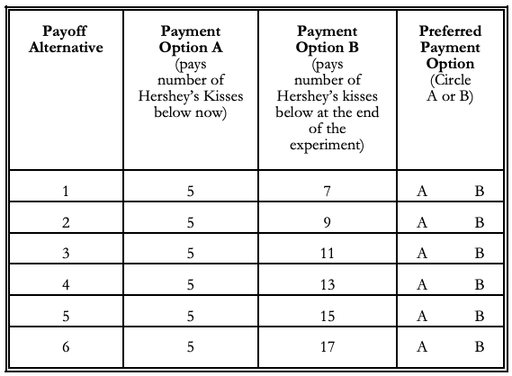

LET US BEGIN THE EXPERIMENT
Please remain quiet throughout the experiment. Do not show your decision to or discuss your decision with anyone else. All decisions will be treated confidentially.
Remember that each payoff alternative is equally likely to be selected, and you are just as likely to be the Assignee as anyone else. Therefore, it is in your best interest to carefully consider your payment options under each payoff alternative and choose the one which you truly prefer if you are the Assignee and that payoff alternative is chosen. Once your decisions are given to the experimenter you will not be able to change them.

PLEASE FOLLOW THESE INSTRUCTIONS
- Please complete your payoff tables. For each payoff alternative we have calculated the associated annual interest rate and annual effective interest rate. Next to each payoff alternative circle the payment option (A or B) you will prefer if chosen to be the Assignee. Make sure that you circle the same choices on both copies of the table.
- Once you have made your decisions, raise your hand. An assistant will quickly inspect your payoff table to ensure there are no blank spaces and that both copies you completed indicate the same choices. The assistant will then collect one copy, and you will keep one copy.
- After everyone’s decisions have been collected the experimenter will need about 15 minutes to get organized. Please take this time to fill out the questionnaire that you receive when you hand in your payoff table.
Notice that we do not ask for your name on any response other than the University-required statement of consent. This statement does not include your ID number. Furthermore, we have no way in which to link your name with your ID number. Therefore, although the experimenters will know the Assignee’s name they will not be able to connect a name to any particular questionnaire. Your responses will be completely confidential.
- Once the experimenters are organized, a ball will be drawn from the Bingo cage, and the payoff alternative will be announced. The Bingo cage will contain balls numbered 1-15.
- Bingo balls with numbers corresponding to the ID numbers of people participating in today’s experiment will be placed in the Bingo cage. A ball will be drawn and the Assignee’s subject ID number will be announced.
- The Assignee will bring his or her copy of the payoff table to the experimenter. The Assignee will be paid based on the chosen payoff alternative and the payoff option circled next to that payoff alternative. This payment option will be kept confidential and will not be revealed to the other participants. The Assignee will be taken to receive the notarized certificate.
- Everyone else will remain seated. The experimenter will call the ID number which is on your payoff table. When your number is called bring your folder of materials to the assistant at front of the room. At this time you will be paid and may leave the experiment.
THANK YOU FOR YOUR PARTICIPATION!

