M. R. Isaac, J. M. Walker and S. H. Thomas (1984), « Divergent evidence on free riding : An experimental examination of possible explanations », Public Choice

Screen 1

WELCOME

This experiment is a study if group and individual exchange behavior. The instructions are simple, and if you follow them carefully and make good investment decisions, you may earn a CONSIDERABLE AMOUNT OF MONEY which will be paid to you in cash at the end of the experiment. Various research foundations have provided funds for this research.

Screen 2

You are a person in a group of 4.
Each of you will be given an investment account with a specific number of tokens in it. All tokens must be invested to turn them into income.

HOW TO INVEST:

There are two ways you can earn money by investing your tokens. Press -NEXT- to find out more about them.

Screen 3

1. The INDIVIDUAL EXCHANGE
For each token you invest in the individual
exchange you get: 1 cents per token.

For example:
If you invest 55 tokens in the individual exchange,
you earn $0.55.
If you invest 140 tokens in the individual exchange,
you earn $1.40.

Press NEXT to continue.

Screen 4
2. The GROUP EXCHANGE
The return on your investment in the group exchange is not so easily determined.
Your earnings depend upon the total investment in the group exchange (your invested tokens plus all of the other token invested by the other people in your group).
Press NEXT to find out more about the group exchanges: press BACK to review the previous instructions.

Screen 5

Rules of the Group Exchange

You and 3 other people are members of a group.

When you invest in the group exchange, how much money you get depends on what you do and also on how much the other group members invest.

The more the GROUP invest, the more you all get from the GROUP exchange.

In your group, each person has an investment account
with a specific number of tokens in int.
The group as a while has 248 tokens. You have 62 tokens.

When you invest in the group exchange, the tokens you invest are no longer yours. THEY BECOME THE PROPERTY OF THE GROUP !

Press NEXT.

Screen 6

The money that the invested tokens earn is also the property of the group. This money is divided up at the end of the period. Each person gets an equal share out every group dollar.

IT DOES NOT MATTER WHO INVEST THE TOKENS IN THE GROUP EXCHANGE. Each dollar is divided up this way.

Press NEXT.

Screen 7

For example:

If you put no tokens in the group exchange, but the other members invest enough to earn $1.00, you earn 25 cents from the group exchange.

If the others invest no tokens in the group exchange, but you put enough for the group to earn $1.00, you still earn 25 cents from the group exchange.

REMEMBER - how much you and the other group members earn depends on how much all of you together put into the group exchange.

Press -NEXT- to see the Payoff Table for the Group Exchange
-BACK- to Review

Screen 8

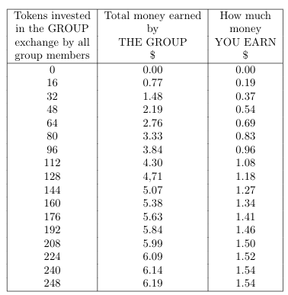

Press NEXT when you are finished.

Screen 9

Example:
Suppose that the members of the group together invest a total of 128 tokens in the group exchange. Look in the table at the line beginning in the number of tokens closest to this total. The appropriate values are underlined. (Press DATA to view the table.)

Screen 10

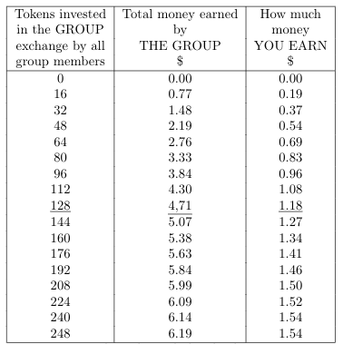

Look to the underlined values.
Press NEXT when you are finished.

Screen 11

You saw from the table that the group gets $4.71 from the exchange. Every group member gets $1.18 from the exchange.
You would receive $1.18 from the group exchange. WHETHER OT NOT YOU DEPOSIT ANY OF YOUR TOKENS IN THE EXCHANGE!

Press NEXT to continue; press shift-BACK to review group investment; press BACK to review the table.

Screen 12

Tips on investing

When you invest, you can divide your tokens in any way you want. That is, you can:

- put all of them into the group exchange

- put all of them into the individual exchange

- put some of them into the group exchange and some of them into the individual exchange

Press NEXT to continue.

Screen 13

STAGES OF INVESTMENT

You will have 10 trials in which you make investment decisions. The profits you make are stored after each Trial and the total profits from all Trials payed to you at the end of the experiment.

When you are asked how you want to invest: you may put all, some, or none of your 62 tokens in the group exchange, and put the remaining tokens in the individual exchange. After you and everyone else in your group has had a chance to invest at this first stage, you will be shown how many of the group's 248 tokens have been put in the group exchange, and how many have been put into the individual exchange. You will also be shown your underline{own} earnings from the group exchange, from the individual exchange, and your total earnings.

Press NEXT to continue.

Screen 14

Practice Trial 0
To give you practice in entering your investments, let's go through an example. Your screen will show the same information it will contain in the actual experiment. Only the directions in the box will not be available during the experiment.
Press NEXT to continue

Screen 15
Practice Trial 0

Press DATA now if you wish to view the profit table,
Press NEXT to continue without viewing the table.
You will be able to view your earnings from each of the previous TRIALS at the beginning of a new investment TRIAL. Press -DATA- to view the tables now

Screen 16

TRIAL
Total Invested | grp | 0
Total Invested | ind | 0

TRIAL

Your profit | grp | 0.00
Your profit | ind | 0.00
Your profit | Total | 0.00

The profit level from each TRIAL will be entered in the table above.
Press -BACK-

Screen 17

Practice Trial 0

You have 62 Tokens.

How many tokens do you wish to invest in the group exchange? 32 ok

How many tokens do you wish to invest in the individual exchange? 30 ok

If you wish to change your investment decision at this time, press shift-BACK- and redo the investment process. If you are satisfied with your decisions, press NEXT to continue.
At this point, you can press shift-BACK- to change your investment decisions for this period. You may do so now if you wish to review the practice trial up to these instructions. If you understand the procedures so far, press NEXT to continue.

Screen 18

Practice Trial 0

You have 62 Tokens.

How many tokens do you wish to invest in the group exchange? 32 ok

How many tokens do you wish to invest in the individual exchange? 30 ok

You earned $1.18 from the group exchange.
You earned $0.30 from the individual exchange.
Total earnings = $ 1.48

Total token investment in group exchange = 128
Total token investment in individual exchange = 120

Press NEXT to go on with the instructions. Press BACK to review the practice trial.

Screen 19

IMPORTANT NOTICE

REMEMBER: At the end of the experiment you receive the sum of your profits from all TRIALS.

DO NOT SPEAK TO ANY OTHER PARTICIPANT!

Press NEXT to continue; press BACK to review the previous page; press shift-BACK to review the entire set of instructions.

Screen 20

Comparing Group and Individual EXCHANGE

The individual exchange gives you a sure return. Also, you have a chance to earn money from the group exchange if any member invest in it.

The group exchange gives you a chance to make more from your tokens invested. But, the earnings from the Group Exchange will depend on the investment decision of all participants.

NOTE: Your individual decision on how much you invest in the private exchange and in the group exchange is not known by the other participants. Only information on total group investment is given to each person.

Do not press NEXT until you are ready to enter the experiment. Once you press NEXT you will not be able to review the instructions. Press BACK to review the instructions in reversed order; press shift-BACK- to review the instructions in their entirety; press NEXT only if you understand all of the instructions.

Screen 21

ARE YOU SURE ?

You will not be able to return to the instructions after leaving this page. If there is any doubt in your mind press BACK.

Once you press NEXT there is no turning back. Press NEXT only of you fully understand the instructions.

